BGA Void Inspection Report
Quantitative & qualitative void analysis per IPC-A-610 / IPC-7095
Board / image | PCBA2_05.jpg
Report generated | 2026-07-09 19:57
Inspection tool | BGA X-ray Void Inspection Tool
Standards applied | IPC-A-610 / IPC-7095
BGA grid / balls analyzed | 256 expected pads, 256 analyzed
IPC VERDICT: ACCEPT WITH PROCESS INDICATORS
No IPC-A-610 defect. 21 ball(s) in the 10-25% process-indicator band (IPC-7095 process guidance).

Key void metrics
Average void ratio | 5.854 %
Median void ratio | 5.9368 %
Worst ball (total void) | 14.8996 %
Worst single void | 10.3005 %
Assessment split | 235 acceptable / 21 process indicator / 0 defect
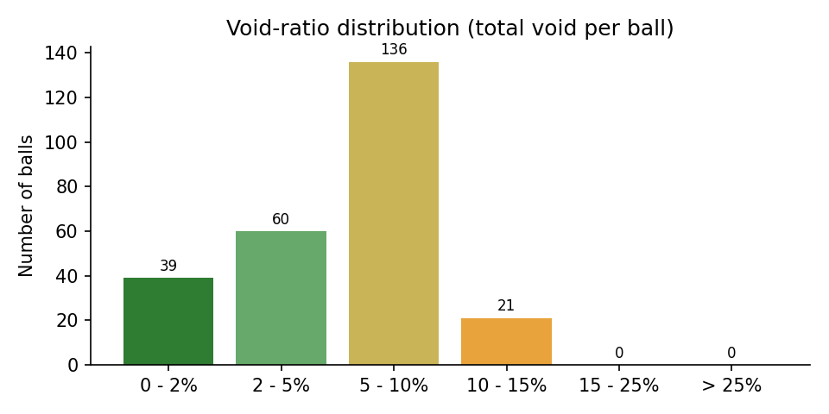

IPC criteria evaluation
Criterion | Source | Limit | Measured | Result
Cumulative void area per ball | IPC-A-610 (Class 1, 2, 3) | <= 25% of ball area | worst ball: 14.90% | PASS
Process indicator band (total void 10-25%) | IPC-7095 process guidance | monitor, not a defect | 21 ball(s) in band | INFO
Largest single void per ball | IPC-7095 (dominant-void guidance) | review above 12.2% area (~35% diameter) | worst single void: 32.1% of ball diameter | PASS
Void location at pad interface | IPC-7095 (30% dia at land) | requires oblique/3D view | not measurable in one top-down 2D X-ray | NOT EVALUATED
Complete ball grid detected | detection integrity gate | all expected pads found | 256 / 256 | PASS

Worst 10 balls by total void
Ball ID | X (px) | Y (px) | Total void (%) | Largest void (%) | IPC assessment
90 | 1868 | 882 | 14.90 | 6.35 | PROCESS INDICATOR
32 | 510 | 280 | 13.42 | 7.38 | PROCESS INDICATOR
33 | 2470 | 424 | 12.73 | 9.64 | PROCESS INDICATOR
7 | 1416 | 122 | 12.31 | 3.50 | PROCESS INDICATOR
10 | 2017 | 123 | 12.31 | 3.98 | PROCESS INDICATOR
207 | 361 | 1941 | 11.90 | 2.96 | PROCESS INDICATOR
66 | 2472 | 727 | 11.76 | 4.98 | PROCESS INDICATOR
180 | 662 | 1786 | 11.67 | 3.65 | PROCESS INDICATOR
82 | 2472 | 877 | 11.41 | 8.32 | PROCESS INDICATOR
113 | 2473 | 1178 | 11.40 | 4.98 | PROCESS INDICATOR

Annotated X-ray (detected voids)
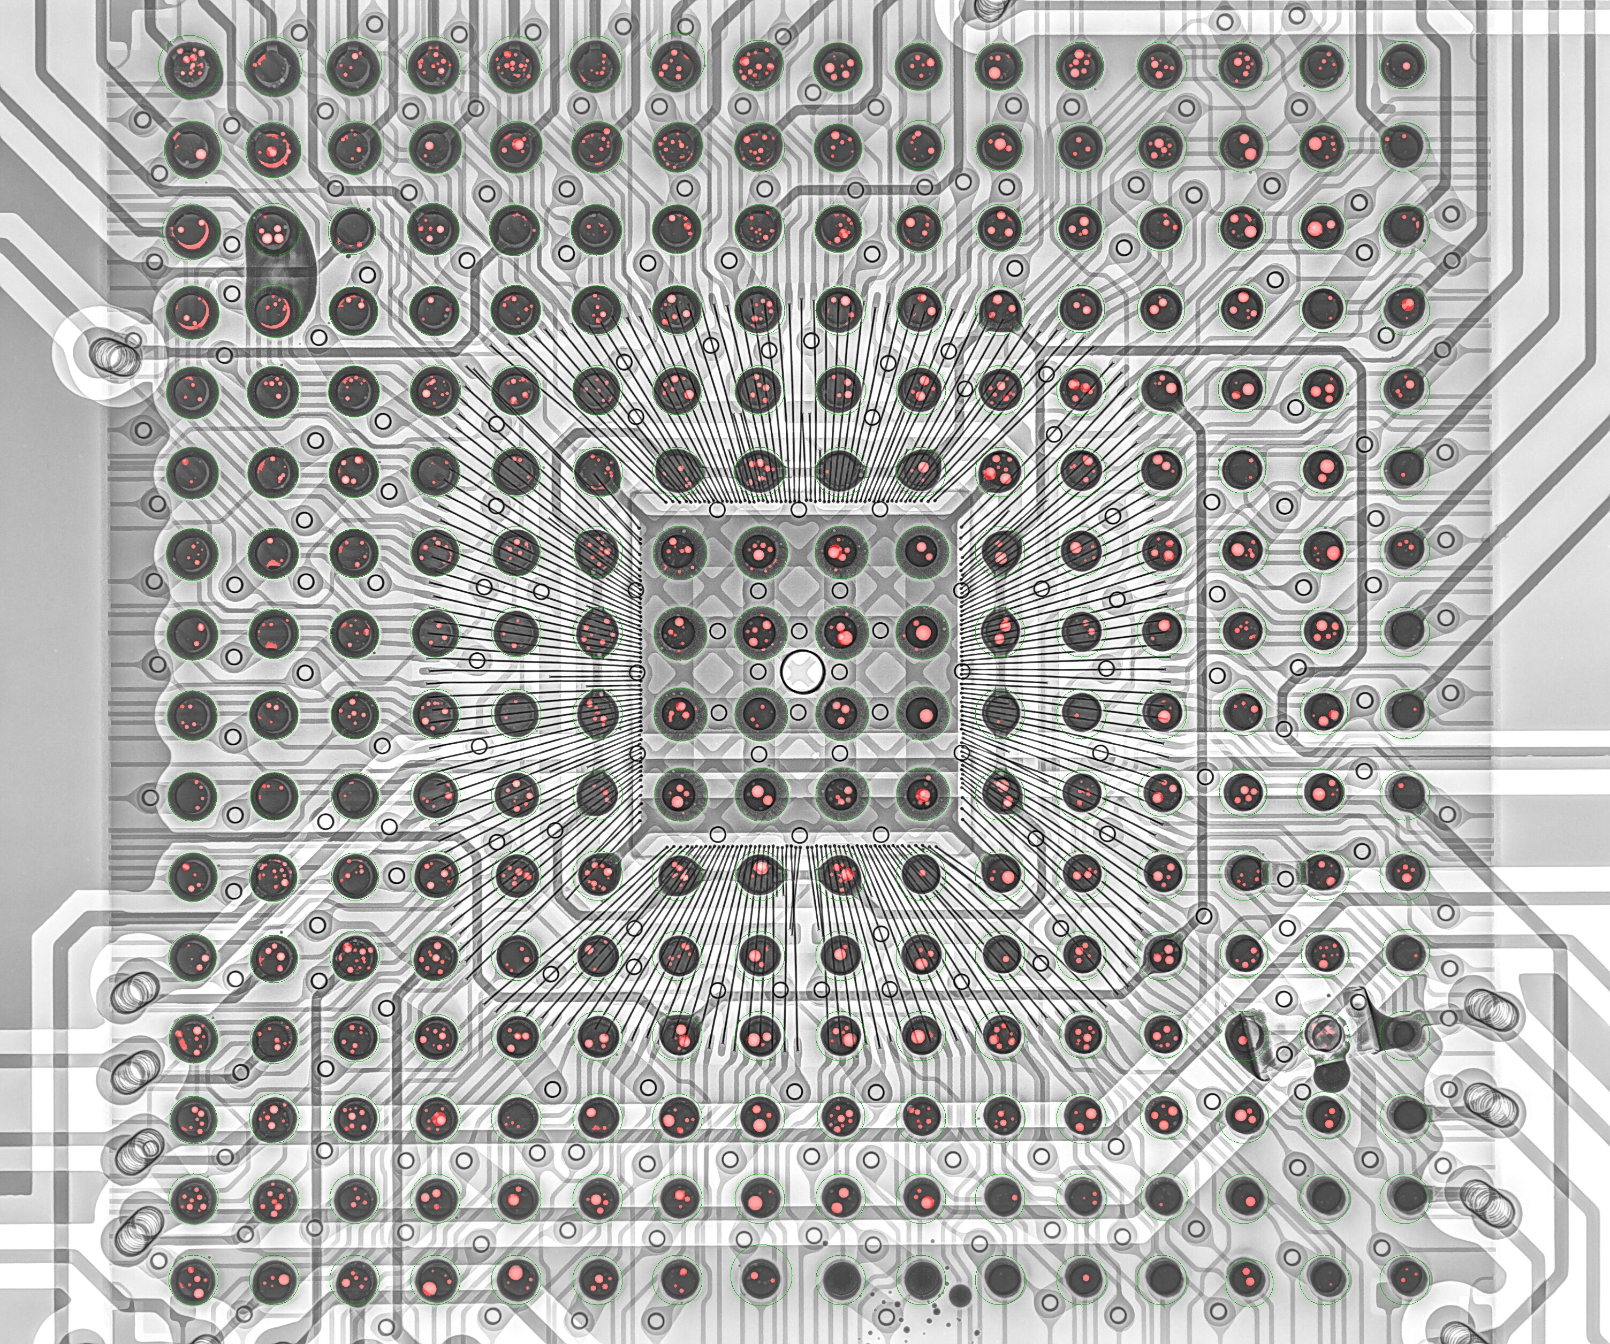

Algorithm analysis - honest assessment

Detection integrity
- Balls detected: 256 of 256 expected grid slots
- Pads placed from grid estimation (no direct evidence): 0
- Mean detection confidence (evidence-backed pads): 1.00
- Ball quality split: 235 PASS / 21 REVIEW / 0 FAIL

Measurement pipeline (what actually produced these numbers)
- 1. CLAHE contrast enhancement + median denoising of the raw X-ray.
- 2. Solder-ball detection: Hough circles + dark-blob evidence, regularized onto the 16x16 BGA grid (affine + homography fit for oblique views, per-ball local snap with non-degradation gates).
- 3. Per-ball void segmentation: median-background subtraction (kernel > ball radius), bond-wire suppression by grayscale closing, residual threshold, then shape filtering.
- 4. Detected void blobs are rendered as fitted circles when they fill >= 45% of the fitted disc (physical voids are spherical gas bubbles); ragged non-circular structures keep their raw contour.
- 5. Component-level sanity filters remove rim arcs, trace stripes, bare-board bleed-through and empty-pad artifacts before metrics.

Classification thresholds applied
- Defect (FAIL): total void >= 25.0% of ball area (IPC-A-610).
- Process indicator (REVIEW): total void >= 10.0% (IPC-7095 guidance).
- Dominant single void (REVIEW): largest void >= 12.25% of ball area (~35% of ball diameter).

Measurement uncertainty - read before trusting decimals
- Projected-area measurement: one top-down 2D X-ray cannot separate package-interface, mid-ball and pad-interface voids; the 25% IPC-A-610 criterion is applied on the projection, exactly as the standard defines it for X-ray inspection.
- Analysis is restricted to the inner 82% of each ball radius; a void hiding exactly on the ball rim can be underestimated.
- Voids smaller than ~10 px^2 (about 0.15% of a ball) are below the detection floor and are intentionally ignored as noise.
- Fitted-circle rendering slightly increases void area versus the raw threshold blob (it includes the faded bubble edge); this is closer to the physical bubble size but adds ~0.3-0.6 percentage points to board averages compared to raw-contour reporting.
- JPEG compression artifacts and CLAHE amplification set a noise floor around 1-2% void ratio; differences below that level are not meaningful.
- On oblique views, perspective foreshortening distorts both ball and void areas; the ratio is partially self-correcting but not perfectly.

Known limitations of this analysis
- Components mounted on the opposite board side project dark shadows between and over balls; the detector anchors circles on grid geometry to resist this, but heavily shadowed balls have reduced void sensitivity.
- Grid slots occupied by vias (no ball populated) are still reported as balls when the slot must be filled; they show ~0% void and near-board brightness.
- Bond-wire suppression (morphological closing) can mask very thin elongated voids lying exactly under a wire.
- The tool measures voiding only; it does not assess head-in-pillow, non-wet opens, bridging or solder-ball shape defects.

Balls to verify manually first (worst 10 by total void)
- Ball # 90 at (1868, 882): total 14.90%, largest single 6.35% -> PROCESS INDICATOR
- Ball # 32 at (510, 280): total 13.42%, largest single 7.38% -> PROCESS INDICATOR
- Ball # 33 at (2470, 424): total 12.73%, largest single 9.64% -> PROCESS INDICATOR
- Ball # 7 at (1416, 122): total 12.31%, largest single 3.50% -> PROCESS INDICATOR
- Ball # 10 at (2017, 123): total 12.31%, largest single 3.98% -> PROCESS INDICATOR
- Ball #207 at (361, 1941): total 11.90%, largest single 2.96% -> PROCESS INDICATOR
- Ball # 66 at (2472, 727): total 11.76%, largest single 4.98% -> PROCESS INDICATOR
- Ball #180 at (662, 1786): total 11.67%, largest single 3.65% -> PROCESS INDICATOR
- Ball # 82 at (2472, 877): total 11.41%, largest single 8.32% -> PROCESS INDICATOR
- Ball #113 at (2473, 1178): total 11.40%, largest single 4.98% -> PROCESS INDICATOR

Grid-estimated pads (verify visually)
- None - every pad was detected from direct image evidence.
Generated automatically by BGA X-ray Void Inspection Tool on 2026-07-09 19:57. Verdicts follow IPC-A-610 (25% cumulative projected void area per ball) with IPC-7095 process guidance; they are based on a single top-down 2D X-ray projection and should be confirmed by an operator for boards flagged REVIEW or REJECT.

